Data Structures and Algorithm
Group Assignment 1

Group Number 1
Department of Electronics and Communication Engineering
Indian Institute of Information Technology Allahabad

Mohd. Wael Abrar
(IEC2021001)
Anurag Jain
(IEC2021002)
Abhishek Rana
(IEC2021003)
Ayush Kumar Gupta
(IEC2021004)

Question- Given an unsorted array of N numbers, find the sum of the second largest and smallest numbers is a prime number or not.
Keywords—Array, unsorted, minimum, second maximum, prime

Introduction
We are given an unsorted array and the problem is to check whether the sum of the smallest and second largest number is a prime number or not. We are trying to provide a solution for the same.

Methodology

Overall Working
Our solution uses basically two algorithms; one is for checking whether a number is a prime number or not and the second is the linear search which is used to find the minimum and second maximum number from the unsorted array. The program takes an array as input and then finds the smallest and second largest number from the array and finally checks if their sum is a prime number or not.

Checking whether a number is Prime or not
A prime number is a number that follows the following two conditions:
- Should be greater than 1.
- Should have only two divisors.
Our algorithm works on the same principle, it works like first it checks whether the number is divisible by 2 and 3 and not 2 and 3 itself, it declares them as non-prime if they are divisible, and declares them prime if they are either 2 or 3 itself. Next, it checks if the number is greater than zero or not and declares them non-prime if they are not. Further in the solution if the number hasn’t been declared prime or non-prime it checks if the number is divisible by any integer less or equal to the square root of the given number. If the number is found divisible by any such integer it is marked non-prime and if it fails all these criteria, it is marked prime.

Linear Search
A linear search, also known as a sequential search, is a method of finding an element within a list. It checks each element of the list sequentially until a match is found or the whole list has been searched. In our solution, we have defined three variables for storing the minimum, maximum and second-maximum number from the array. In the beginning, we have initialized “maximum” and “second-maximum” as to the smallest integer possible that can be assigned and the “minimum” to the largest integer that can be assigned in the C programming language. Then we check for the rest of the array for the minimum and maximum. It checks each element from the first element of the array, if the element is less than the number stored in the variable “minimum” then it changes the value of minimum to the current element, then if the element is greater than the number stored in the variable “maximum”, it assigns the value of “maximum” into “second-maximum” and also assigns the current element as the value of “maximum”. If the element does not verify both, we check if the second maximum is smaller than the element or not, if it is we assign the current element as the value of variable “second-maximum”. If not the element is ignored.

Results

Run 1
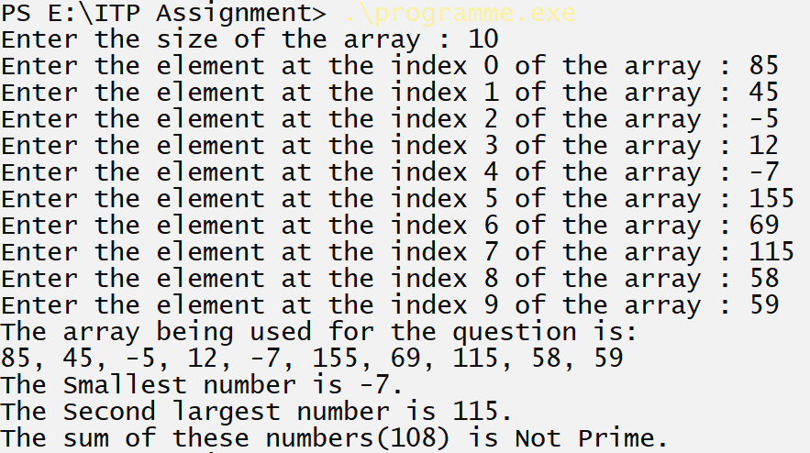
Figure 1 When the sum is not prime. Runtime (without input) = 0.898 seconds

Run 2
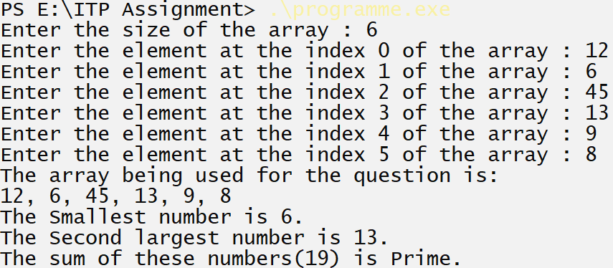
Figure 2 When the sum is Prime. Runtime (without input) = 0.247 seconds

Run 3
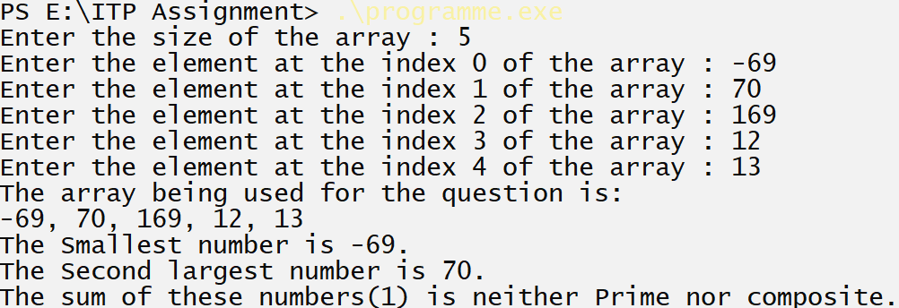
Figure 3 When the sum is 1. Runtime (without input) = 0.254 seconds

Conclusion
Clearly, our proposed solution to the provided question works absolutely like it is meant to.

Program
#include<stdio.h>
#include<stdbool.h>
#include<math.h>

// checking a number is prime or not
bool checkPrime(int n)
{
if ((n == 2)||( n == 3)){
return true;
}
else if (((n % 2) == 0)||((n % 3) == 0)||((n<=0))){
return false;
}
else {
for(int i = 5; i <= sqrt(n); i++){
if (n % i == 0){
return false;
}
}
}
return true;
}
int main()
{
int n;
printf("Enter the size of the array : ");
scanf("%d",&n);
int a[n];

for(int i=0;i<n;i++){
printf("Enter the element at the index %d of the array : ", i);
scanf("%d",&a[i]);
}
int min, max, max2;
max2 = max = -2147483647;
min = 2147483647;
printf("The array being used for the question is:\n");

// linear search

for(int i=0; i<(n); i++){
if(i==0){
printf("%d", a[i]);
}else{
printf(", %d", a[i]);}
if(min>a[i]){
min = a[i];
}if(max<a[i]){
max2 = max;
max = a[i];
} else if(max2<a[i]){
max2 = a[i];
}
}

printf("\nThe Smallest number is %d.\nThe Second largest number is %d.\n", min, max2);
if(checkPrime(min+max2)){
if(min+max2 == 1){
printf("The sum of these numbers(1) is neither Prime nor composite.");
}else
printf("The sum of these numbers(%d) is Prime.", min+max2);
} else {
printf("The sum of these numbers(%d) is Not Prime.", min+max2);
}
return 0;
}

References
The idea of checking whether a number is prime or not is partially taken from [1].
- C Program to Check Whether a Number is Prime or Not https://www.programiz.com/c-programming/examples/prime-number

